EXPERIMENT 4

CREATE TABLE student_63_(
roll_no int primary key,
Physics int,
Chemistry int,
Mathematics int);

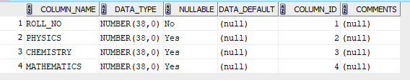

INSERT INTO student_63_ values (1,15,25,35);
INSERT INTO student_63_ values (2,10,14,30);
INSERT INTO student_63_ values (3,20,22,45);
INSERT INTO student_63_ values (4,12,11,20);
INSERT INTO student_63_ values (5,10,20,35);
INSERT INTO student_63_ values (6,22,24,40);
INSERT INTO student_63_ values (7,14,16,25);
INSERT INTO student_63_ values (8,19,21,42);
INSERT INTO student_63_ values (9,16,13,27);
INSERT INTO student_63_ values (10,21,23,50);
DESC student_63_;
SELECT *FROM student_63_;

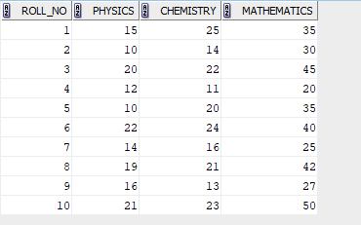

1) SELECT avg(Physics) AS class_average_physics FROM student_63_;
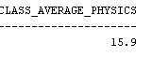

2) SELECT max(Mathematics) AS highest_marks_maths FROM student_63_;

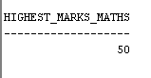

3) SELECT min(Chemistry) AS lowest_mark_chemistry FROM student_63_;

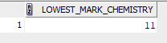

4) SELECT COUNT(*) AS pass_physics_count FROM student_63_ WHERE Physics>=12;

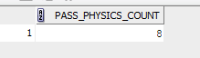

5) SELECT roll_no
FROM student_63_
WHERE physics >= 12
AND chemistry >= 12
AND mathematics >= 25;

